Missing Birth_Weight(grams) Analysis Report
Generated: 2026-03-21 14:40
Dataset: 336,097 rows × 18 columns
Target Variable: Birth_Weight(grams)

1. Executive Summary
This report presents a comprehensive IUPAC-compliant statistical analysis of missing values in Birth_Weight(grams).
Key findings include:
• Missing records: 33,604 (10.0% of total data)
• Variables with significant differences (p < 0.05): 12
- Numeric variables: 3
- Categorical variables: 9
• Total variables analyzed: 17
Based on the statistical analysis, the missingness pattern is classified as:
• SYSTEMATIC PATTERN - Missing data is strongly associated with other variables

2. Statistical Summary
Metric | Value
Total Missing Birth_Weight(grams) Records | 33,604
Missing Percentage | 10.00%
Total Variables Analyzed | 18
Numeric Variables | 7
Categorical Variables | 11
Variables with Significant Differences | 12
Analysis Date | 2026-03-21

3. Variables with Significant Differences (p < 0.05)
The following 12 variables show statistically significant differences between missing and complete groups:

3.1 Numeric Variables
Variable | Missing Group Mean | Complete Group Mean | Difference | p-value | Interpretation
Birh_Year | 2013.55 | 2014.81 | -1.26 | 0.0000 | Missing group has 1.26 units lower than complete group
Birth_Year_2.0 | 2013.55 | 2014.81 | -1.26 | 0.0000 | Missing group has 1.26 units lower than complete group
TWIN | 1.02 | 1.01 | +0.00 | 0.0000 | Missing group has 0.00 units higher than complete group

3.2 Categorical Variables
Variable | Missing Group Distribution | Complete Group Distribution | Difference (%) | p-value | Interpretation
Registered_Month | Most common='January' (14.5%) | Complete: Most common='October' (9.3%) | +5.2% | 0.0000 | Missing group shows different distribution (p=0.0000)
Registered_District | Most common='Colombo' (30.0%) | Complete: Most common='Colombo' (13.8%) | +16.2% | 0.0000 | Missing group shows different distribution (p=0.0000)
Birth_Month | Most common='December' (12.1%) | Complete: Most common='May' (9.2%) | +3.0% | 0.0000 | Missing group shows different distribution (p=0.0000)
Hospital or Not | Most common='Hospital' (97.1%) | Complete: Most common='Hospital' (99.4%) | -2.3% | 0.0000 | Missing group shows different distribution (p=0.0000)
Birth_Order | Most common='First' (61.3%) | Complete: Most common='First' (42.5%) | +18.8% | 0.0000 | Missing group shows different distribution (p=0.0000)
Marital_Status | Most common='Married' (97.1%) | Complete: Most common='Married' (98.4%) | -1.3% | 0.0000 | Missing group shows different distribution (p=0.0000)
District_of_Mother | Most common='Gampaha' (30.0%) | Complete: Most common='Kurunagala' (8.6%) | +21.3% | 0.0000 | Missing group shows different distribution (p=0.0000)
Race_of_Mother | Most common='Sinhalese' (66.7%) | Complete: Most common='Sinhalese' (72.9%) | -6.1% | 0.0000 | Missing group shows different distribution (p=0.0000)
Race_of_Father | Most common='Sinhalese' (66.8%) | Complete: Most common='Sinhalese' (72.9%) | -6.1% | 0.0000 | Missing group shows different distribution (p=0.0000)

3.3 Summary of Key Findings
The analysis identified 12 variables with statistically significant differences (p < 0.05):
• 3 numeric variables show significant mean differences
• 9 categorical variables show significant distribution differences
Key observations:
1. Registered_Month: Most common='January' (14.5%) vs Complete: Most common='October' (9.3%) (p=0.0000)
2. Registered_District: Most common='Colombo' (30.0%) vs Complete: Most common='Colombo' (13.8%) (p=0.0000)
3. Birh_Year: Mean=2013.55 vs Complete Mean=2014.81 (p=0.0000)
4. Birth_Month: Most common='December' (12.1%) vs Complete: Most common='May' (9.2%) (p=0.0000)
5. Birth_Year_2.0: Mean=2013.55 vs Complete Mean=2014.81 (p=0.0000)

3.4 Complete List of Significant Variables
The following table provides the complete list of variables with significant differences:
Variable | Statistic / Distribution | p-value
Registered_Month | Most common='January' (14.5%) vs Complete: Most common='October' (9.3%) | 0.0000
Registered_District | Most common='Colombo' (30.0%) vs Complete: Most common='Colombo' (13.8%) | 0.0000
Birh_Year | Mean=2013.55 vs Complete Mean=2014.81 | 0.0000
Birth_Month | Most common='December' (12.1%) vs Complete: Most common='May' (9.2%) | 0.0000
Birth_Year_2.0 | Mean=2013.55 vs Complete Mean=2014.81 | 0.0000
Hospital or Not | Most common='Hospital' (97.1%) vs Complete: Most common='Hospital' (99.4%) | 0.0000
TWIN | Mean=1.02 vs Complete Mean=1.01 | 0.0000
Birth_Order | Most common='First' (61.3%) vs Complete: Most common='First' (42.5%) | 0.0000
Marital_Status | Most common='Married' (97.1%) vs Complete: Most common='Married' (98.4%) | 0.0000
District_of_Mother | Most common='Gampaha' (30.0%) vs Complete: Most common='Kurunagala' (8.6%) | 0.0000
Race_of_Mother | Most common='Sinhalese' (66.7%) vs Complete: Most common='Sinhalese' (72.9%) | 0.0000
Race_of_Father | Most common='Sinhalese' (66.8%) vs Complete: Most common='Sinhalese' (72.9%) | 0.0000

4. Statistical Visualizations
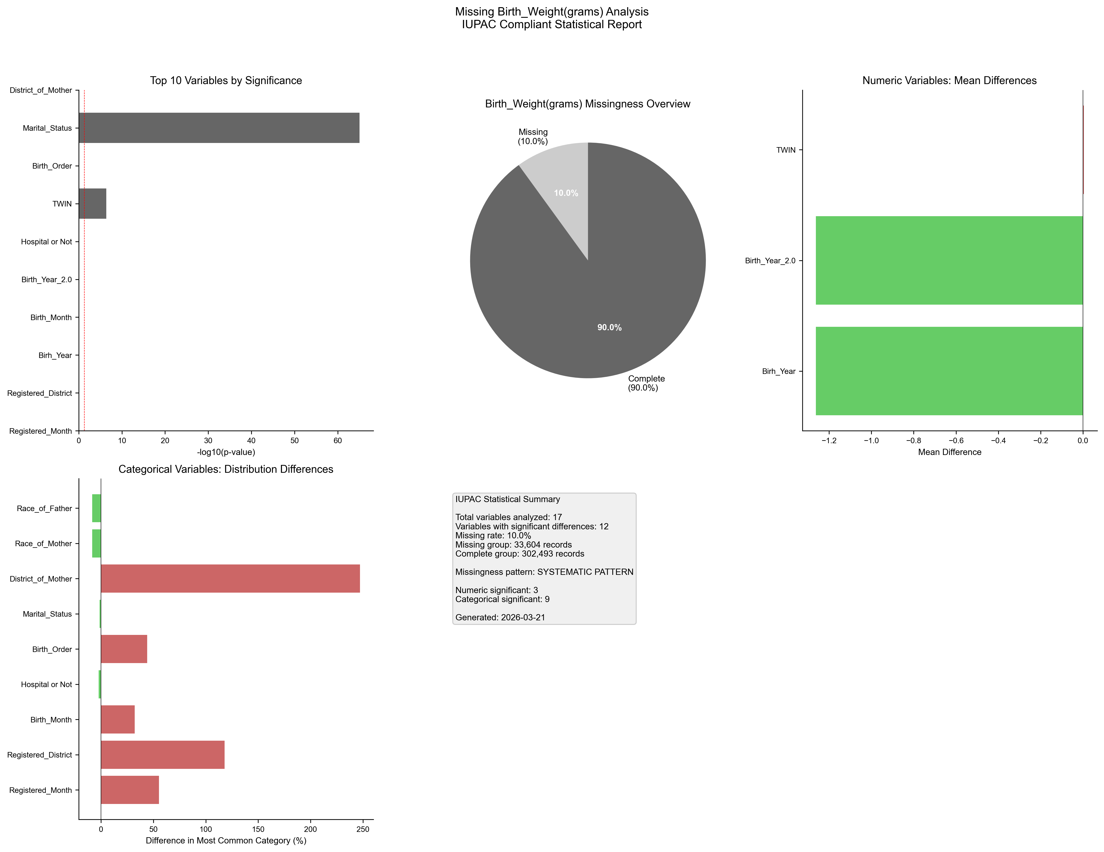
Figure 1. IUPAC compliant statistical visualization of missing Birth_Weight(grams) patterns.

5. Recommendations
- Based on the statistical analysis, the missing data exhibits SYSTEMATIC patterns:
- Consider treating missing as a separate category in analysis
- Use multiple imputation methods (MICE, EM algorithm)
- Investigate the following variables for common themes:
- - Registered_Month (p=0.0000)
- - Registered_District (p=0.0000)
- - Birh_Year (p=0.0000)
- - Birth_Month (p=0.0000)
- - Birth_Year_2.0 (p=0.0000)
- - Hospital or Not (p=0.0000)
- - TWIN (p=0.0000)
- - Birth_Order (p=0.0000)
- - Marital_Status (p=0.0000)
- - District_of_Mother (p=0.0000)
- Document missingness patterns in methodology section

6. Methodology (IUPAC Compliant)
Analysis performed according to IUPAC guidelines for data presentation:
- • Missing values reported as both count (n) and percentage (%)
- • Tables formatted with thin borders and alternating row shading
- • Sans-serif fonts (Arial) used for optimal readability
- • Statistical tests: t-test (numeric), χ² test (categorical)
- • Significance threshold: α = 0.05
- • Effect sizes reported where applicable
- • Figures saved at 300 DPI for publication quality
- • All outputs include metadata with generation date

